**Leader Overview**

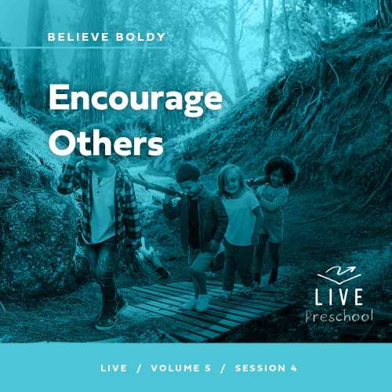

**Volume Overview**

**Believe Boldly**

*The gospel message is shocking to many, shocking because of its implications. God has made himself known to us and promised to place His Spirit into our heart. We have been given direct access to Him. The Bible encourages us to come to Him with boldness. Our boldness in approaching Him is not from our words or our achievements. Instead, it’s based on God’s promises. So we ask, remembering His power and faithfulness. And we encourage those around us to do the same. Believe boldly.*

**Session Overview**

**Encourage Others**

*In this* **Live** *session, preschoolers will discover the story of four people who figured out a very creative way to bring their friend to Jesus. They demonstrate the blessing friends can be in our life and how we can have faith for others. Preschoolers will think about friends they have who they can have faith for.*

**Bible Lesson**

Four Friends’ Enormous Faith Moves Jesus to Heal Their Friend

[Mark 2:1–12](https://ref.ly/logosref/Bible.Mk2.1-12)

**Faith Fact**

I can have faith for others.

**Faith Verse**

[1 Corinthians 16:13–14](https://ref.ly/logosref/Bible.1Co16.13-14) (NLT)

Be on guard. Stand firm in the faith. Be courageous. Be strong. And do everything with love.

**Preparing for the Session**

**Leader Preparation Time: 20–25 Minutes**

|  |
| --- |
| ***You Will Need***  ***Preservice Activities***  *• Toys*  *• Newspaper*  *• Animal crackers*  ***Large Group***  *• Bible*  *• Worship songs (Song suggestions: “Living Color” Lyric Video by Elevation Church Kids; “Brave” Motions Video by Saddleback Kids Worship; “Little Life” Lyric Video by Hillsong Kids; “Never Be Shaken” Lyric Video by New Life Kids)*  *• For groups not using a phone or tablet only, add:*  *• Projector or TV*  *• Laptop*  *•* ***Faith Fact Sound*** *video (bell ringing)*  *•* ***Faith Fact Slide***  *•* ***Faith Verse Slide***  *•* ***Faith Verse Video***  *•* ***Bible Lesson Video A***  *•* ***Bible Lesson Video B***  ***Small Group***  *• Plastic spoons, one per kid*  *• Table tennis balls, one per group*  *•* ***Small Group Activity Page****, one per kid*  *• Crayons or markers*  *• Bath towel, one per group*  *• Doll or stuffed animal, one per group*  *• Chair, one per group*  *• Coffee filter, one per group*  *• Water-based markers*  *• Spray bottle with water*  *• Blacker permanent marker*  *• Paper to protect table*  *• Baking sheet*  *• Aluminum foil*  *To access session content and videos from a computer, visit:* [***BibleEngagementProject.com/downloads***](https://bibleengagementproject.com/downloads) |
| ***Getting Ready***  ***Preservice Activities***  *• Set out toys and snacks.*  ***Large Group***  *• Download videos and slides if needed.*  *• Select worship song(s) and have them ready to play.*  ***Small Group***  *• Print copies of the* ***Small Group Activity Page****, one per kid*  *• Set the chair about 10 feet from the starting point.*  *• Cover the table with paper before drawing on the coffee filter.*  *• Draw the outline of a heart in the center of the coffee filter with the permanent marker and write the word Love in the middle.*  *• View* [*this video*](https://www.youtube.com/watch?v=sbv5FuT2YM4) *for reference.*  ***First time leading* Live *for Preschool? Check out the*** [**Facilitator Guide**](https://0b769b0ed3569ef9d18b-f88d8272f61086866d50d048b43ef630.ssl.cf2.rackcdn.com/sites/biblengagementproject/Listen_Facilitator_Guide.pdf)**.** |

**Preservice Activities**

*See what’s needed at the beginning of the session.*

**Bible Story Warm-Up**

Has anyone ever seen one of these? *(Hold up the newspaper.)* If you haven’t, that’s okay. This is called a newspaper. Before computers and TVs, this was one way people would find out what was going on in their city, country, and even around the world. They didn’t have cell phones or the Internet like we do now. If something important happened, they could read about it in the newspaper.

In Bible times, people usually found out what was happening when someone else told them. People mostly had to use their own voice to let others know the exciting things that were happening.

What is one way that you can learn about something exciting? *(Allow responses.)*

How can you tell others exciting news? *(Allow responses.)*

What is the most exciting news you want to share with us?

In our Bible story today, we’ll find out what happened when a group of friends heard that Jesus was coming to town. They did something very exciting! I’m so glad I get to learn about it from God’s Word with you today.

**Snack**

**Animal Crackers**

We have a great snack today. These crackers remind me of all the different animals God created. Some animals fly, others swim, and some walk on the ground like you and me. Before you eat your crackers, I want you to move them around like each of the animals would move. If you have a bird, make it fly in the air. If you have an elephant, make it walk around on the table. Let’s see all the fun ways that you can move them.

• *Hand out the snack and encourage the kids to help the animals move.*

• *Allow time for kids to eat the snack.*

You all had some creative ways to help these animals move around. Just like you helped the crackers move, we’ll learn how some friends helped someone who couldn’t walk move around. I can’t wait to learn more about it with you.

**Free Play**

*Any extra time can be spent playing with toys.*

**Transition**

*A few minutes before service begins have kids make their way to the large group area and sit in their designated areas.*

**Large Group**

**25 Minutes**

*See what’s needed at the beginning of the session.*

**Introduction**

Hi, everybody! It’s so great to be here with you to hear an amazing story from the Bible. *(Hold up the Bible.)* One of the things that’s in our story is mud. How many of you like playing in the dirt or mud? *(Group response)* How many of you don’t like the feeling of mud or dirt on your hands? *(Group response)* Well, you’ll have to be listening for the time when mud shows up in our Bible story.

Today, we’ll hear about a group of four men who wanted Jesus to heal their friend. They wouldn’t let a crowd or even a roof stop them from getting their friend to Jesus. If you’re glad God has given you good friends, give a high five to the friend sitting next to you. *(Group response)*

**Faith Fact**

Today, we’ll learn how we can help our friends have faith in Jesus. To help us remember, our Faith Fact today is **I can have faith for others.**

• *Show the* ***Faith Fact Slide.***

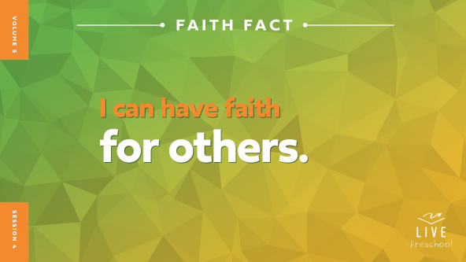

Let’s say it together. **I can have faith for others.** Let’s clap on each word as we say it again. *(Clapping)* **I can have faith for others.** That sounded so good! Let’s do it one more time. *(Clapping)* **I can have faith for others.**

**Bible Time**

One of my favorite things to do is learn from God and His Word, the Bible. We have a great friend to explore Bible stories with. Let’s check in with Lizzy.

• *Play* ***Bible Lesson Video A****.*

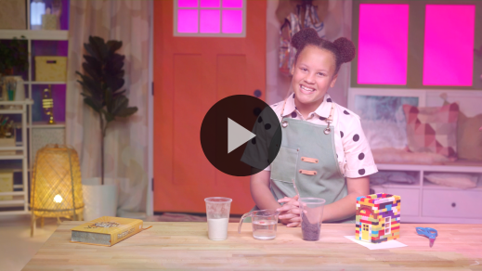

Lizzy gave us a great question, so we need some time to think about what might have happened next. Let’s worship, and then we’ll talk about what might be next in our Bible story.

**Worship**

The crowd in our Bible story wanted to be near Jesus so much that they were willing to get really close to each other. The people filled the house where Jesus was. People even stood outside so they could hear what Jesus had to say. I’m so glad that we can be close to Jesus and talk to Him all the time. He is always with us, and He is here with us now. Let’s tell Jesus how much we love Him.

**Praise**

Who wants to thank Jesus for the friends He’s put in your life? Shake hands with the friend next to you. *(Group response)*

Are you glad Jesus is with us all the time? Wave your hands up high. *(Group response)*

Who wants to thank Jesus for His great big love that surrounds all of us? Spin around one time. *(Group response)*

**Sing**

We’ve used our arms and legs to thank Jesus. Now, let’s use our voices to worship Him by singing.

• *Lead the kids in singing one or two songs. See song suggestions at the beginning of the session.*

**Prayer**

Jesus deserves all our praise. He deserves all our love. Let’s bow our heads and talk to Him.

|  |
| --- |
| *Dear Jesus, we love You! You deserve all our praise. You deserve all our worship. Thank You for loving us and wanting to be close to us. We want to grow closer to You today and learn from Your Word. Amen.* |

**Bible Time cont’d**

• *Start* ***Bible Lesson Video B*** *and pause on the image of the two choices.*

I think Grandpa and Lizzy are coming back soon! Let’s think about what happens next in our Bible story. Can you put on your thinking caps? *(Demonstrate.)* What do you think? *(Point to “X house” graphic.)* If you think the four friends gave up on getting their friend to Jesus because the house was crowded, rest your chin on your hands like you’re giving up. *(Point to “eyes” graphic.)* If you think the four friends looked for a new way into the house, put your hand over your eyes like you’re looking for something. *(Group response)* Let’s find out if you’re right! Here’s Lizzy.

• *Play* ***Bible Lesson Video B.***

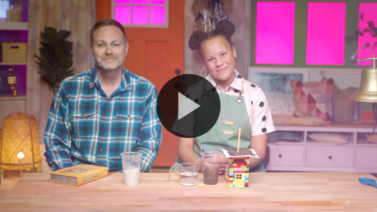

I am so glad God puts friends in our life, aren’t you? I’m also thankful Jesus has let me be a part of your life.

**Response Time**

*Play a worship song quietly.*

Let’s respond to the truth we’ve discovered today. Think about a friend who either helps you have faith or who needs your help to have faith in Jesus. Picture that person in your mind.

• *Pause briefly while kids think of someone.*

• *Have the kids repeat phrases of the prayer after you.*

|  |
| --- |
| *Dear Jesus, I thank You for good friends. I pray for my friends who help me have faith in You. I also pray for my friends who I can help have faith. Show me how I can help them. Amen.* |

**Faith Verse**

Do you want to know what helps us have faith in God? One thing is learning Faith Verses from the Bible. Let’s say our Faith Verse and do the actions together.

[1 Corinthians 16:13–14](https://ref.ly/logosref/Bible.1Co16.13-14) (NLT)

Be on guard. Stand firm in the faith. Be courageous. Be strong. And do everything with love.

• *Show the* ***Faith Verse Video.***

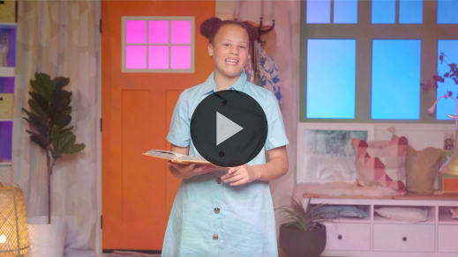

**1 Corinthians** *(hands at waist, spread apart, palms up and out)*

**16:** *(hands together like a clap)*

**13–14** *(hands opened to “book”)*

**Be on guard.** *(fierce face and cross arms in X in front of body)*

**Stand firm in the faith.** *(jump and land with feet spread apart)*

**Be courageous.** *(salute)*

**Be strong.** *(flex bicep muscles)*

**And do everything with love.** *(place hands over heart)*

That was wonderful, friends! You’ve done a great job learning our Faith Verse!

**Closing**

Have you had as much fun as I have learning about Jesus? *(Group response)* Let’s see. This is how much I love it. *(Spread arms out as wide as possible.)* Show me how much you’ve loved learning our Bible story and Faith Verse. *(Group response)* Wow! That’s a lot! I’m so glad we could learn that friends can help us have faith and that we can have faith for our friends.

• *Play the* ***Faith Fact Sound*** *video (bell ringing).*

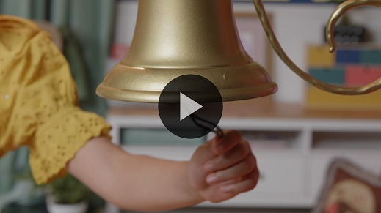

Did you hear that sound? It’s our Faith Fact bell! It’s time to say our Faith Fact one more time.

• *Show the* ***Faith Fact Slide.***



Let’s say it together. **I can have faith for others**. Let’s point to the friend next to us as we say it one more time. **I can have faith for others.**

**Dismissal to Small Groups**

You all learned that so well! Now, it’s time to go to our circles where we’ll spend time in our very special small groups.

• *Dismiss the kids by groups.*

|  |
| --- |
| ***Leader Tip:*** *This can be done by assigning color teams or by age groups. Note that some young preschoolers may not know their age. Using a colored sticker, jersey, or wristband will help separate the kids and help identify their small groups.* |

**Small Group**

**25 Minutes**

*See supplies and prep instructions at beginning of session or in each activity below.*

|  |
| --- |
| ***Leader Tip:*** *Small groups can alternate to each circle, or all groups can do each activity at the same time. If you choose to alternate, you will need at least one leader per circle.* |

**Circle 1**

**Group Connection**

**I Like to Move**

|  |
| --- |
| ***You Will Need***  *• Plastic spoons, one per kid*  *• Table tennis balls, one per group*  *No prep needed for this activity.* |

In our Bible story, four men took their friend to Jesus. They had to move carefully and work together to carry their friend who couldn’t walk. *(Hold up a ball.)* Let’s see if we can work together to move something carefully. Our job is to pass this ball all the way around our circle using plastic spoons. Every time the ball drops, we’ll freeze and say our Faith Fact together. Let’s practice it before we begin. **I can have faith for others.** Amazing! Now, let’s play this game.

• *Have the kids sit in a circle and give each kid a spoon. Then, start the game.*

• *Remind kids to say the Faith Fact each time the ball drops to the floor.*

• *Allow kids to play for as long as time allows.*

That was super fun! You did such a good job of working together to move the ball carefully. That reminds me of how well the four friends worked together to get their friend to Jesus. They had faith that Jesus would heal their friend, and He did! It’s so amazing that we can have faith for others, too.

**Circle 2**

**Activity Page Time**

**Faith for Others**

|  |
| --- |
| ***You Will Need***  *•* ***Small Group Activity Page****, one per kid*  *• Crayons or markers*  ***Getting Ready***  *• Print copies of the* ***Small Group Activity Page****, one per kid.* |

Today, we’ve learned that we can have faith for others. In our Bible story, four amazing friends had faith that Jesus would heal their friend, so they didn’t let anything stop them from taking him to Jesus. Does anyone remember what all they had to do to get their friend to Jesus? *(Allow responses.)*

There were a lot of things that they had to do. They had to carry him through the town to the house where Jesus was. Then, they had to carry him up on to the roof because the house was full of people and they couldn’t get him inside to see Jesus. The biggest thing they did was cut a hole in the roof and lower their friend down to Jesus.

• *Hand out a copy of the* ***Small Group Activity Page*** *and crayons to each kid.*

Because of their faith, Jesus healed their friend. That reminds me of our Faith Fact: **I can have faith for others.** Color the picture of the four friends lowering their friend to Jesus. As you color, tell me about friends you have that you can have faith for.

• *Talk with kids about their friends’ needs as they complete the activity.*

• *During the activity, interrupt and practice the Faith Fact:* **I can have faith for others.**

• *Play the* ***Faith Fact Sound*** *video****.*** *Review the Faith Fact even if you can’t play the sound.*



**Circle 3**

**Feet-to-Floor Game Time**

**Four Friends Relay**

|  |
| --- |
| ***You Will Need***  *• Bath towel, one per group*  *• Doll or stuffed animal, one per group*  *• Chair, one per group*  ***Getting Ready***  *• Set the chair about 10 feet from the starting point.* |

We learned about some pretty amazing friends in our Bible story today. They cared so much about their sick friend that they carried him all the way to see Jesus. That’s what we’ll pretend to do for our game today.

• *Show kids the towel and the doll.*

Four of you will work together to carry our “friend” safely around the chair and back to our group. Remember that our friend doesn’t feel well, so you’ll want to be gentle. When you get back to the group, say the Faith Fact. **I can have faith for others.** Then, four more friends will carefully carry our friend. Let’s see if everyone can care for our friend.

• *Play the game until time runs out.*

Well done, everyone! As our love for one another grows, it will become easier to share our faith with others. Like the friends the Bible story had faith for their friend, we can have faith for our friends!

**Circle 4**

**Hands-On Learning**

**All You Need Is Love**

|  |
| --- |
| ***You Will Need***  *• Coffee filter, one per group*  *• Water-based markers*  *• Spray bottle with water*  *• Blacker permanent marker*  *• Paper to protect table*  *• Baking sheet*  *• Aluminum foil*  ***Getting Ready***  *• Cover the table with paper before drawing on the coffee filter.*  *• Draw the outline of a heart in the center of the coffee filter with the permanent marker and write the word Love in the middle.*  *• View* [*this video*](https://www.youtube.com/watch?v=sbv5FuT2YM4) *for reference.* |

Our Faith Verse teaches us how we can live for God. It reminds us to be on guard, stand firm in our faith, be courageous, and be strong. Then, it tells us to do everything in love. Sometimes it’s easy to do things in love, such as giving a hug or a high five to someone. Other times it’s hard to do things in love, such as cleaning your room when your parent tells you to instead of playing. The more we do things in love, the more it starts to rub off on other areas of our life. Let’s look at it like this.

• *Hold up the coffee filter.*

Right now, this has a heart on it, but not much else. Let’s think of some ways that we can show love. Every time you think of something, you can draw a small heart on here with a different colored marker.

• *Allow kids to suggest ways to do things in love. (Examples: Give someone a hug, draw a picture for someone, send a card to a family member, help clear the table, walk the dog, etc.)*

• *On the paper-covered table, have kids continue drawing hearts until the entire coffee filter is filled with color.*

This looked pretty great with all our hearts of love, but love is best when it’s shared. Let’s see what happens if I spray water on all our hearts.

• *Place the coffee filter on the baking sheet lined with aluminum foil.*

• *Spray water on the coffee filter until the colors mix and fill in the white spots on it.*

The more colorful hearts we had, the easier it was for them to spread to one another. The more we do everything with love, the easier it is to show love to others. I’m so glad to have a Faith Verse that has been teaching us about this. There’s nothing more fun than learning God’s Word. Let’s practice saying it together.

• *Review the Faith Verse with actions.*

**1 Corinthians** *(hands at waist, spread apart, palms up and out)*

**16:** *(hands together like a clap)*

**13–14** *(hands opened to “book”)*

**Be on guard.** *(fierce face and cross arms in X in front of body)*

**Stand firm in the faith.** *(jump and land with feet spread apart)*

**Be courageous.** *(salute)*

**Be strong.** *(flex bicep muscles)*

**And do everything with love.** *(place hands over heart)*

That was amazing! We can trust that God’s Word is true. The more we read it, the easier it will be to memorize it. The Bible gives us a guide to always know how to live.

**Dismissal**

• *Play the* ***Faith Fact Sound*** *video (bell ringing).*



• *Show the* ***Faith Fact Slide.***



I can’t believe our time together is almost done. I’ve had so much fun today! I think we should all say our Faith Fact together one last time. Ready? **I can have faith for others.** Great job! Wow, I love getting to learn about the Bible with you! I can’t wait to see you again next time.

• *Send home the* ***Small Group******Activity Page*** *with each kid.*

• *Remind parents that there are* ***Family Devotions*** *available on the app to do with their kid.*

• *Tell everyone the date and time for the next session.*